

**Fairley House School**

Candidate Information Pack

Occupational Therapists vacancy for September 2025

Full time Band 6 with opportunity to train as a specialist teacher.

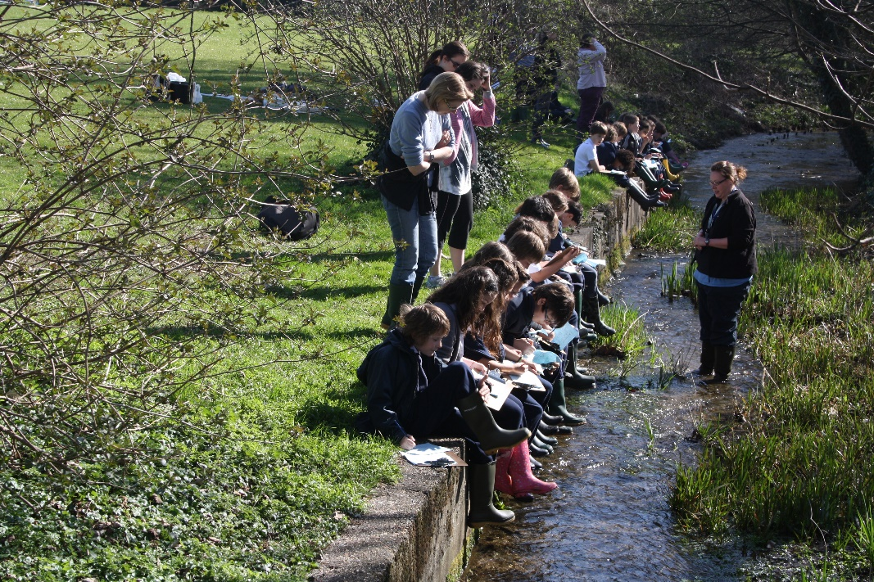London’s leading day school for children with specific learning differences

***and all of a sudden...nothing is impossible.***

**Introduction to Fairley House**

Fairley House is located in central London across two well-connected sites. The senior department (Years 8 to 11) is based in Westminster and the junior department (Years 3 to 6 and currently Year 7) is based in Lambeth. It is approximately 10-15 minutes walk between the two sites.

The school was established in 1982 by Daphne Hamilton-Fairley whose husband was killed by an IRA bomb in 1975. Mrs Hamilton-Fairley was a speech and language therapist who had been providing therapy for dyslexic children at home. As a parent with four children, two of whom were dyslexic, she knew how poorly understood dyslexia was and how badly it was addressed, mainly through hospital clinics.

She resolved to set up a school for dyslexic children as a memorial to her husband, hence the name Fairley House. She aimed to combine a medical focus: speech and language therapy and occupational therapy within a warm and nurturing educational setting. This pioneering, transdisciplinary approach has remained at the core of what we do and is part of our magic formula for success that transforms the learning outcomes of our students.

Currently the school is thriving with around 210 pupils, and we have had recent approval to expand our capacity to 250. We continually look at how we can remain at the forefront of the field of SpLD and our staff frequently contribute to ongoing research and best practice. This knowledge is shared through regular community outreach to local schools and other organisations to help improve the prospects of children in London and around the UK.

As well as being a school we also have an in-house Assessment Centre and offer Teacher Training to teaching professionals who wish to broaden their CV and areas of expertise.

**Distinctive features of the school and its governing structure.**

We are registered with the DCSF as an independent special school for specific learning differences. We have children from a range of socio-economic backgrounds and wide geographical area thanks to our enviable reputation. We have a mixture of privately funded and part-public funded students. Currently around 58% of children have an Education, Health and Care Plan, the vast majority paid for by local authorities (LAs) with some coming from the poorest London boroughs. It is a tribute to our children that this diversity is embraced, and friendships are forged by children from very different backgrounds and circumstances. Children do not arrive in September of Year 2 and stay until the Summer Term of Year 11 because the aim is to equip them with the confidence, skills and knowledge to return to mainstream schooling as and when it is appropriate for that individual child.

The school is a charity and is run by a Board of Governors.

#### **For Autumn 2025**

**We are looking for an experienced, full time, paediatric occupational therapist (band 6) who wants to broaden their skill set by completing our Level 5 SpLD diploma, to join our team at Fairley House School in Central London SW1, in September 2025.**

This is an exciting opportunity to join an outstanding independent school catering for students with Specific Learning Differences (for example, dyslexia, dyscalculia, and dyspraxia), which really does change pupils’ lives. We offer small class sizes with an outstanding curriculum provision.

You will work closely with a transdisciplinary team consisting of educational psychologists, speech and language therapists, and specialist teachers.

Occupational therapy provision is varied, and you will be involved with assessments (using the most up-to-date assessments), direct therapy provision, and in-class therapy support. Our therapists use a variety of treatment approaches, and you will have a varied and fulfilling caseload. You will also support our students' literacy development as a specialist teacher after completion of our Level 5 SpLD diploma.

You will be supported to transition into this role with mentoring; and will have the opportunity to develop your knowledge and skills and to grow within your career. Fairley House School supports professional development through our excellent inset program, parent-professional evenings, as well as opportunities to attend external courses.

We are looking for a permanent and full-time Band 6 occupational therapist, with experience in paediatrics, who is willing to complete our Level 5 SpLD diploma. Training or experience in Sensory Integration and/or the co-op approach is beneficial. We provide excellent benefits, such as access to a generous pension scheme and free school lunches.



Dear Candidate

We are so pleased that you are interested in applying for the post of Occupational Therapist at Fairley House School. We hope that our application pack gives you all the information you need but if you do have any further questions, please do not hesitate to contact us.

Please see the job description and person specification enclosed in the pack and please address all key areas when submitting your application form and personal statement.

We are a supportive organisation and pride ourselves on our commitment to staff wellbeing, professional development and a welcoming environment.

Our incentive package includes:

* Fairley House operates its own competitive pay scale, and salaries are enhanced to reflect our status as a leading Central London SEN Independent School.
* Stake holders pension scheme with Standard Life
* Small class sizes
* Free school lunch during term time
* Buffet lunches during INSET
* End of Term staff events
* Complimentary tea/coffee and fruit
* Cycle to work scheme.
* Employee assistance line which includes online counselling
* Excellent transport links (close to mainline Waterloo and Vauxhall, numerous central London bus routes)
* The opportunity to work in the centre of London with attractions such as Tate Britain, Westminster Abbey, Lambeth Palace and the London Eye on our doorstep.

We are keen to attract a diverse range of professionals who will contribute to the ongoing success of the school. If you would like a confidential chat about the roles and ambitions of Fairley House then feel free to contact Sally Fenton on [careers@fairleyhouse.org.uk](mailto:Managercareers@fairleyhouse.org.uk)

**Fairley House is committed to the safeguarding and welfare of children and successful applicants must be willing to undergo an enhanced DBS check, personal and professional reference check and a medical.**

I look forward to receiving your application.

Yours sincerely,

**Michael Taylor**

**Head**

**Job Description**

See attached Band 6 Job Description

# Person Specification: Therapist

|  |  |  |
| --- | --- | --- |
|  | Essential | Desirable |
| Qualifications | Good honours degree  Membership of the Health Professionals Council  Evidence of, and commitment to, continuing professional development  Willingness to undertake the Level 5 (SpLD) diploma through Fairley House | Specific learning difficulties qualification |
| Experience | The therapist should have experience in:  Working with children with specific learning difficulties  Standardised Paediatric Assessments  Therapy provision | Other relevant specialisms, such as ASD  Sensory integration (OTs)  Cognitive Orientation to Occupational Performance Model |
| Knowledge and understanding | Therapists should have knowledge and understanding of:  Specific learning difficulties, including dyslexia, dyspraxia and specific language impairment  Assessments  Good report writing  Effective therapy techniques  Working on a withdrawal basis  Working in a classroom in collaboration with the teacher  Legislation concerning Equal Opportunities, Health & Safety, SEN and Child Protection. | In addition, therapists might also have knowledge and understanding of:  Transdisciplinary working |
| Skills | Therapists will be able to:  Promote the school’s aims, ethos and whole school approach to specific learning difficulties  Provide interesting, multi-sensory therapy sessions  Manage behaviour positively  Write IEPs with SMART targets based on initial assessment or previous IEPs  Work collaboratively with other adults in the classroom  Plan sessions collaboratively with teachers  Develop effective relationships with pupils, parents, staff and governors  Communicate effectively (both orally and in writing) to a variety of audiences  Develop literacy and numeracy in children with specific learning difficulties, or be willing to develop these skills  Contribute to a happy, challenging, effective learning environment.  Ability to set up equipment for motor classes (OTs) | In addition, the therapist might also be able to:  Develop initiatives which improve the school |
| Personal characteristics | Committed  Empathetic  Enthusiastic  Dynamic  Organised  A reflective practitioner  Able to work in a fast-paced and demanding environment |  |

FAIRLEY HOUSE SCHOOL - TRAINING OPPORTUNITIES

**Level 5 Diploma in Teaching Learners with Specific Learning Difficulties (Dyslexia)**

**Fairley House School (FHS) and CPD have offered a Certificate in teaching learners with specific learning difficulties since January 2006 to those who teach English. The next course will start in September 2025.**

**This well-recognised qualification provides Continuing Professional Development for teachers working with specific learning difficulties affecting the acquisition of literacy and numeracy. It is suitable for SENCOs, learning support teachers, therapists and classroom teachers wishing to develop specialist skills in this area.**

**Candidates will attend lectures and seminars after the end of the school day on a Wednesday (from 4:30 to 7:00) our Educational Psychologist will contribute to the course, as will members of the school’s speech and language and occupational therapy teams with tutors presenting the majority of lectures, group seminars and individual tutorials.**

**Candidates are required to teach a student with literacy difficulties for 12 hours and a student with literacy and numeracy difficulties for 6 hours.**

**Candidates will be assessed teaching both their students and this will usually be done by tutors submitting a videoed lesson. Candidates must gather a portfolio of evidence which demonstrates knowledge of SEN legislation and the roles of Specialist Teachers, Educational Psychologists and Speech and Language Therapists. The portfolio must also demonstrate skills in identifying and assessing students with specific learning difficulties, planning teaching programmes, delivering and evaluating lessons, as well as reflecting on the candidate’s own performance. There are formal guidelines to follow in order to achieve the qualification. The expectation is that those taking OCR will need to allow at least 10 hours of study per week on top of attending the course.**

**The course runs for a year. (Fairley House English staff are funded in-house and are required to work in the school for at least 2 years following the course. If not, they would be liable for the course costs or part, thereof, depending upon circumstances). It covers CPD fees, lectures and seminars, plus tutorial support and assessment of the candidate’s work over 3 terms. If, for any reason, this extends over and above the three terms, staff could be liable for additional marking costs.**

**Fairley House School is now the only Central London venue offering the course. The course draws upon the expertise of FHS and working with dyslexic and dyspraxia students. It combines theory and practice and will give candidates practical skills they can use.**

**The course is offered to candidates from many other schools and offers additional networking opportunities.**

**For staff who are not teaching English, we offer an in-house short course on teaching pupils with specific learning difficulties, leading to a Fairley House Certificate.**

**For all other enquiries relating to professional development, please contact HR**

**Why work at Fairley House School.**

**Comments from current staff**

“What I love most about working at FHS is the team approach to helping our pupils. I believe that this holistic approach of looking at the whole child is what makes us so successful at achieving our ultimate aim, which is to get them back into mainstream schooling, equipped with all the strategies they need to flourish. I find it very insightful to work with a child across different contexts (such as within a speech and language therapy session, a Writing lesson, a Reading lesson or within lunchtime clubs) and this is what enables me, as a speech and language therapist, to be able to ensure that the skills that I am working on are functional to the child within all of their lessons, throughout the school day. I love working collaboratively with the very talented and creative teachers here to plan and co-teach lessons together, where we are both working towards the same common goals.

The children here are also inspirational. Often, they have had very difficult experiences of education prior to coming here, where learning has been such a challenge, and they sometimes have a very low opinion of themselves. However, they are very brave and resilient and willing to give learning another go, and it is amazing to see them succeed and recognise their achievements for themselves. We quickly see their self-esteem soar as they realise what they are capable of, and this gives them the confidence to take more risks with their learning”.

Alex

“I was on my way home from a parents evening and was yet again reminded how fortunate I am to be working at Fairley House. After a particularly emotional meeting, I left close to tears when a mother described how much her daughter had flourished since being at the school. On a daily basis I know that I am contributing to unlocking the potential of children who previously have seen themselves as a failure. I work alongside a fantastic team and together I know we make such a difference to our students and their families, giving them a safe haven in which they can achieve their potential”.

Miriam

###### Ready to apply?

Please contact Sally Fenton, HR Manager, [careers@fairleyhouse.org.uk](mailto:careers@fairleyhouse.org.uk) about this vacancy if you require further information, would like to book a tour or for an application form.

Please see our website for more details about Fairley House

[www.fairleyhouse.org.uk](http://www.fairleyhouse.org.uk)

Closing date: 6/6/25